# Overview

A somewhat time consuming but critical aspect of scheduling is the estimating process. During this process you need to decide if you are doing a top down or bottom up approach and where you will get your estimates from. Planning for task estimates and resource estimates will be required along with learning more about how Project’s scheduling engine uses your estimates in its calculations.

The next logical step would be sequencing of activities which is controlled by task dependencies and linking features. You need to become familiar with the four types and how they can be tailored with lag and lead time. If there is an opportunity to disable tasks at a point in time, the inactivate feature can also be applied.

# Overview of Estimating

Estimating is the ability to make an educated guess as to the duration, and work of a task. Project Management is both an art and a science. Estimating task durations and work draws on the project manager’s skills and experience during the estimation process. Estimates take into consideration factors such as resource skill, history, and experience. In this lesson we take a look at estimating duration and work.

## How Project 2013 Defines and Calculates Work and Duration

It would be helpful to understand the formula that will be driving the scheduling of the tasks before you enter your estimates:

Work = Duration * Units (quantity of a resource)

OR

Duration = Work / Units (quantity of a resource)

## Estimating Techniques

* Top down estimating: used when performing the same types of projects frequently. Top-down estimating allows for estimating the length of a phase. The details for tasks will follow. Manual scheduling mode in Project 2013 allows for this type of estimating model. You can use this method when you do not have a lot of information about the project but would like to start getting something down while working toward a project schedule.
* Bottom up estimating: estimating each task work package or deliverable of the project (this could be at the task level) will allow for the accumulated roll up of the values to create the length of the project. The roll up will accumulate at the summary task levels as totals for duration, work and cost. In turn, the summary tasks will roll up to the project summary task for a grand total for the project.

## What to Estimate?

* Estimate duration (length of time) in minutes, hours, days, months, etc.
* Estimate work (amount of work) in minutes, hours, days, months, etc.
* Estimate duration and work in minutes, hours, days, months, etc.

To create consistency within an organization it is recommended that an estimating standard be established. Most schedulers estimate work in hours and duration in days. Longer projects might be estimated using work in days and duration is weeks. Having a standard will help create a consistency across an organization.

## Where Do the Estimates Come From?

Estimates may come from the project manager, team members, subject matter experts, stakeholders, historic data, experience, etc.

## How Do You Get Good Estimates?

Ask the right people: look for the most experienced person in a specific skill area. Chances are, they have worked a project similar to or have actually performed the work in the past. These types of people can be invaluable to a project manager for estimating.

Ask the performing resource: if you are lucky enough to know who your resources will be for the project, the performing resource is always the best source for an estimate. However, how you ask the resource for the estimate will make a difference. If you ask for an estimate, most people are thinking about fitting the work into their current workload. Framing the question from the point of view that the project will be worked some time in the future will result in a more accurate response. They should only consider how long (or how much work) it would take to perform the task regardless of the specific timeframe.

Subject Matter Experts: always a good source for advice.

Padding, slack, and time reserve should be included in any schedule. Every organization and project management methodology has its own approach. The important point is that extra time should be built into all schedules to help manage the inevitable contingencies that will occur during the performance of all projects. If padding, slack or time reserves are not included in the planning, the schedule will not be realistic and will result in a reduced probability of completing the project as planned.

If the work is increased to allow for contingencies, the cost will also increase. Consider increasing duration which will extend the length of time and not necessarily effect cost.

## Estimating for Unknown Resources

Most project managers plan the work for a project and find out what specific resources will perform the tasks in the future. Tasks might require a specific skill level but the quality of the unfamiliar resource is unknown. How do you plan for unknown resources?

When estimating tasks, consider estimating a task for a senior level resource or a junior level resource:

* The senior level person would accomplish the task faster and would cost more.
* The junior level resource would cost less but needs more time and training.

Outsourcing resources: although there is a quantity of highly qualified contract resources, the recommendation is to estimate these tasks at the junior level. You will need to account for a learning curve, assimilation into your organization and ramp up time. The project manager might request a specific skill level but it is unknown whether or not that skill will be available when the project requires it.

## Entering Estimates

The Entry table of the Gantt chart is designed for easy entry of task estimates. Adding the Work column to the view will enable adding work estimates.

To insert the Work column in to the Entry table of the Gantt Chart view:

1. Tasks → Gantt Chart (the default value will be the Entry table)
2. Right click on the column heading Start
3. Select Insert Column
4. Click on the “W” key on the keyboard
5. Click on Work

For each task enter one of the following:

* A duration value
* A work value
* A duration and a work value

Valid entry values:

* 1m = 1 minute
* 1h = 1 hour
* 1d = 1 day
* 1w = 1 week
* 1mo = 1 month
* 1 y = 1 year

Abbreviations of the time values may be customized in the Schedule options:

File → Options → Advanced → Display options for this project

Duration entries will be scheduled as work days as defined by the project calendar.

Physical days (actual day count including non-working days) may also be achieved by using the Elapsed time. By placing an “E” in front of the letter in the duration field, the value will be scheduled in physical number of days. For example: 13 ed = 13 physical days.

In the example below note:

* Task 1 – 5 business days
* Task 2 – 1 day, 40 hours of work
* Task 3 – 5 days, 20 hours of work
* Task 4 – 5 edays – elapsed time or physical days

Note the scheduling difference:

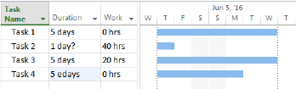

1. After inserting the Work column into the table, enter Duration, Work, or Both. [6-1 Enter Estimates.tif]

Other helpful information:

* When task durations are entered, a “?” will be added within the duration field. This “?” represents that the task information has not been finalized and is considered estimated. This indicator is optional and may be turned off at File → Options → Schedule and un-checking the following options:
* Show that scheduled tasks have estimated durations
* New scheduled tasks have estimated durations
* Manual scheduling mode for a task has the benefit of not requiring values in duration, start and finish columns. Text may be added as a note to the scheduler. If the task mode is changed to automatic scheduling, the text will be lost and, the software will enter a valid value. Scheduling modes are discussed in Manual vs Automatic on page 152. In the view below note the values in the duration, start and finish columns for Task 5:



1. Task 5 is an example of a Manual Scheduled task. Task 6 is an Automatic scheduled task. [6-2 Manual v auto task shot.tif]

Inserting Effort-driven and Type columns will allow for setting these values for each task as well. As discussed in Options on page 100, each task will be unique in the nature of the work to be performed. As a result, these settings should be adjusted to determine what task type and effort-driven values are appropriate for a task.

# Concept of the Scheduling Engine

Dynamic scheduling is the use of task relationships and dependencies to drive the sequence and ultimately the timing of the schedule. Project’s scheduling engine supports dynamic scheduling in automatic scheduling mode.

This means that as the project progresses and you make adjustments to tasks, Project automatically recalculates the effect on subsequent tasks. This will also show the project manager if the overall schedule is extended and provide analysis opportunity to monitor if the change creates multiple critical paths, potential resource constraints, and so on.

Project will also highlight those tasks affected by a change so the project manager can easily see the ripple effect of the current proposed task changes. Project 2013 can aid the scheduler in exploring alternate scenarios as a what-if analysis.

If constraints (which will be discussed in Constraints on page 192) are utilized to lock in task dates, the dates will disable Project’s built-in scheduling engine and a project manager will not be able to see the effects downstream in the schedule. Maintaining this dynamic visibility is vital in effectively and pro-actively managing a schedule. This is why it is a best practice to not use constraints, unless necessary and appropriate to.

# Sequencing

Project 2013 calculates the duration of a project based on task durations and how task dependencies are created between tasks. Establishing the order of the tasks is called Sequencing. Sequencing is concerned with establishing the order tasks should or could be performed. Arranging tasks in the most efficient order for the project is not an easy exercise. Sometimes, the order of the tasks is very evident and at other times, more complicated. The task sequencing order is up to the scheduler and needs to be focused on what is right for a specific project.

For example, the following tasks are tasks that someone would do when they come home after work and before they go to bed:

1. Arrive Home
2. Eat Dinner
3. Walk the dog
4. Run an errand
5. Read the mail
6. Clean up the dinner dishes
7. Cook dinner
8. Go to Sleep
9. Get the mail
10. Watch the news

Take a minute to write down the numbers of the tasks above in the order you would perform these tasks. If you have some post-it notes you can write the task names on the notes and move the notes around to achieve the sequencing order.

Did you notice that some tasks have a forced relationship?

* You can’t eat dinner until you have cooked dinner.
* You can’t read the mail until you get the mail.

Other relationships will work in a more random order:

* Run the errand.
* Watch the news.

Try this exercise again taking into consideration that you have a second person helping you achieve these tasks.

What you might have noticed this time you sequenced the tasks:

* The project took a shorter length of time.
* The work was divided over the workers.
* Some tasks were performed with the people working together and others were performed by only one worker.

Compare your task list to others in the class. You might see that the work will get done but others have a different opinion as to the order the tasks will be completed. Is one list more right than another list?

What you are seeing is the art of project management. Projecting what will work best for a given situation is derived from experience, opinion and the workers performing the tasks. Project provides task relationships to support task sequencing which is discussed in the next section.

# Creating Task Dependencies

Once the tasks are entered into the project schedule, the next step is to consider in what order the tasks should be performed. Many tasks will have a flexible order and others will have a forced order of performance. Establishing the order of the tasks is one of the factors that will help calculate the timeline of the project schedule. A dependency is the name given to the relationship established between the tasks used to establish the order of tasks. If dependencies are not created, Project 2013 will not be able to accurately predict and adjust dependent future tasks based on completed work.

## Task Dependency Types

Project 2013 allows for 4 types of task dependencies. These dependencies establish the order that the tasks will be performed. Dependencies may also be referred to as links, relationships or relationships between tasks. The result of creating task relationships is a network of related tasks establishing a time line. When referring to linked tasks the following terms will apply:

* A task that has a relationship directly before a task is known as a predecessor task
* A task that has a relationship directly after a task is known as a successor task

In the view below there are 4 tasks. The relationships are established as link lines between tasks.

* The predecessor task or task that comes before is the “Paint bedrooms and Family Room” task.
* The successor task or task that comes after the “Replace carpeting” task is the “Repair roof” task.

Pointing to a link line between tasks will display information regarding the task relationship. Notice the pop-up information box which shows the details of the relationship between the “Repair roof” task and the “Fix up completed” task.

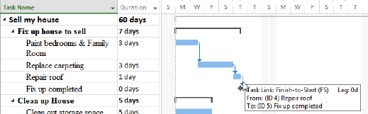

1. View of linked task dependencies. [6-3 Dependencies.tif]

Not all dependencies are the same. Some tasks will start at the same time where others might be scheduled one after the other. To facilitate scheduling needs, there are 4 dependency types which are:

* Finish-to-start
* Start-to-start
* Finish-to-finish
* Start-to-finish

The details of each of the relationship types is described below:

* Finish-to-Start (FS)
* Default dependency for the Project 2013
* Task 1 must complete before Task 2 can begin
* This relationship type creates a waterfall effect

Example: Drive to the restaurant, then eat dinner   
Build a wall then paint the wall

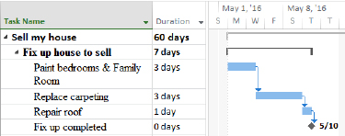

1. This is an example of a Finish-to-Start relationship. [6-4 Finish to start.tif]

* Start-to-Start (SS)
* Tasks that are scheduled to start at the same time

Example: You can start to clean out the Storage space at the same time you have the painters painting the bedroom and family room.

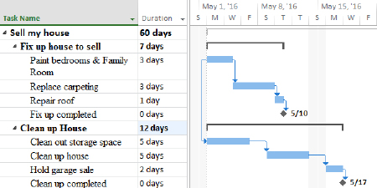

1. Tasks Paint bedrooms & Family room is related Start-to-Start with Clean out storage space. [6-5 Start to start.tif]

* Finish-to-Finish (FF)
* Tasks that are scheduled to finish at the same time but not required to start at the same time.

Example: The section of work below can all start when the previous section is completed. These tasks will start at different times, but they all need to be completed by the same point in time.

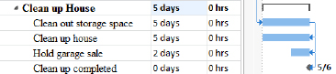

1. The tasks above are in a Finish-to-Finish relationship. [6-6 Finish to finish.tif]

* Start-to-Finish (SF)
* The start date of the predecessor task will determine the finish date of the successor task.
* This is the least used dependency type.
* Example: When the new software module comes on line, the old software will be taken off line

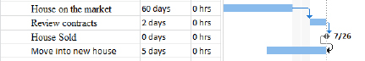

1. Example of Start-to-Finish relationship. [Start to finish shot.tif]

## Task Relationships and Manually Scheduled Tasks

When working with manually scheduled tasks, errors might result using dependencies. A warning is displayed when tasks are linked and dates are entered into the start or finish columns. The calculation of the project duration might not match the duration calculated when the entered dates are taken into consideration. Figure #.8 is an example of an error created when the duration entered for a manually scheduled summary task is smaller than the sum of the detail tasks contained in the summary grouping. Note the bar below the summary task brackets is longer than the brackets and there are dots around the Gantt bar for the House on the market task. There are also squiggly lines under the Finish dates for several tasks.

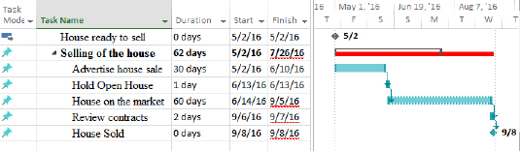

1. Manually scheduled tasks displaying error message. [6-7 Error on manually scheduled tasks.tif]

To correct this type of error, Project 2013 has a feature called Task Inspector. Right click on the red error line and the following choices appear. Select the Fix in Task Inspector option and correction choices are displayed.

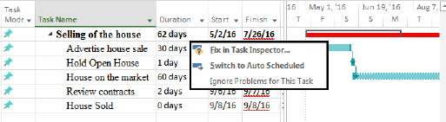

1. Error displayed on Manually scheduled task. Right click on error to display resolution options. [6-8 error message viewed.tif]

Below is the result of clicking on the Fix in Task Inspector option for the task. Note the error message is no longer visible and the task in error has been rescheduled.

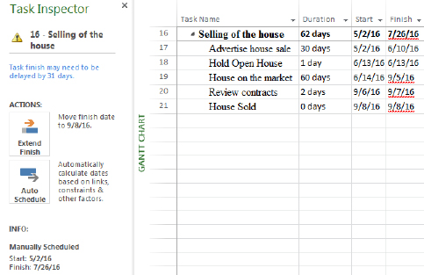

1. Options to resolve the error offered in Task Inspector. [6-9 Task inspector.tif]

Task Inspector will be discussed in Methods for Resolving Resource Conflicts on page 296.

## Best Practices for Using Dependencies

Links between tasks will allow you to create a network of related tasks. The network will show the order the tasks will occur. Below are some best practices which should be considered when creating relationships:

* All tasks should have both a predecessor and a successor. The timeline for the project is based on task duration and relationships. If tasks are not linked in the network of tasks, their duration will not be accounted for within the timeline. Making sure all tasks are included will avoid surprises at the end of a project.
* When creating dependencies or relationships, apply the rule – because I can, is it a good idea? Do not link every task to every other task.
* Think about what task pushes or influences another task. If a task is late, what other tasks will be affected? Link only tasks with a direct effect on a successor task. Ask yourself what needs to be completed before you can do the next step and if it is late, which tasks will be affected.
* Link detail tasks and milestones only. The completion of tasks will push the milestones or the short term goals. Linking summary tasks means that an entire section of work must be completed before the next section may be started. Ask yourself if that is true for your situation before linking at the summary level. Linking summary tasks is not recommended.
* Tasks should always be linked to push milestones. For example: define what the definition of “project completed” is. If multiple parallel paths must be completed to conclude the project, they should all be linked to the ending milestone. If any of the parallel paths takes longer than planned, the milestone date will be pushed out in time.

In the example below “Paint bedrooms & Family Room” is the starting task for the project. All 3 sections of work can start when the project starts. All 3 sections must be completed before the house is ready to sell. If any of the sections take longer, each section has the ability to push the ending milestone or when the house is ready to sell. The longest of the parallel paths will be considered the critical path or the project section that determines the timeline of the project.

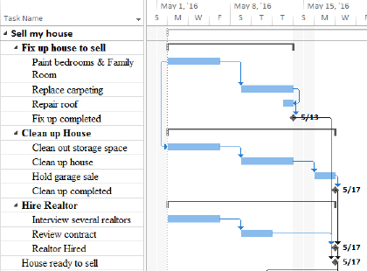

1. Example of multiple parallel paths pushing an ending milestone. [6-10 parallel paths.tif]

* Create as many parallel paths as possible to shorten the schedule. Use of the Start-To-Start and Finish-To–Finish relationships will help create parallel paths and shorten the project time line. Be aware, however, just because you can schedule tasks in parallel, you might not have the resources to perform the work which could result in extending the timeline.
* Do not link tasks based on a resource. Some people will plan tasks to occur at specific times because they think that a resource will be available at that time. Chances are the expected resources will not be available at the planned point in time because other tasks for that resource have changed. Plan the schedule for the work required and plan/arrange for required resources as the time draws nearer to when the task will be performed.
* Links may be external to the project. Project 2013 will allow dependencies to exist in other projects that are linked to tasks in your project. This is similar to links in Excel. In Excel, if links between files are created and the files are relocated, the links will be broken. Project 2013’s links between project files will work the same way.

Project 2013 also offers the option for tasks that are moved or added within the schedule to automatically link in a Finish-to-Start relationship or not be linked at all. This is a personal preference and may be applied to a specific project or all projects viewed on your desktop.

To view or change this option: File → Options → Schedule

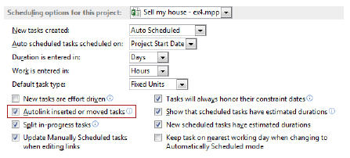

1. Scheduling options. [6-11 Scheduling options.ai]

# Lead & Lag

Relationships between tasks are not always absolutely defined as described with relationships. Allowing for Lead and Lag time will help refine a schedule to bring it more in line with the actual timeline for the project. Lead and Lag time will allow for wait time between tasks and overlap of task activities.

In this section we will discuss:

1. What is Lag time?
2. What is Lead time?
3. Best Practices for using Lead and Lag time

## What is Lag Time?

Lag time is used to provide wait time between tasks. The time will be expressed in business days or specified project calendar working days. Lag time should be used to extend the timeline of the project when only duration needs to be added to a schedule and you will not add work or cost. For example: New concrete is poured and you must wait 6 days before you can drive on it. The time must occur but no work or cost is added to the task. A dependency must first exist between tasks before Lag time can be created.

To create Lag time:

Double click the relationship line between tasks where you would like to add the lag time. The task dependency dialog box below will appear. In figure #.13, there are 2 tasks. After the Paint bedrooms and Family Room task is completed you decide that you would like to wait 3 days for the paint to dry before Replacing the Carpeting.

To add Lag time between tasks:

1. Double click on the link line between tasks. The Task Dependency Box will be displayed.
2. Add time to the Lag box.
3. Click OK.

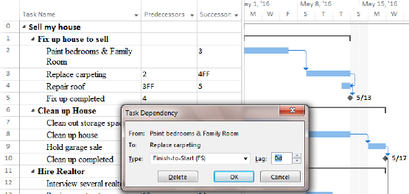

1. Task Dependency box before lag time is added. [6-12 Task Dependency box without Lag time.tif]

The result of adding a 3 day lag is displayed below. Note the values in the predecessor and successor columns. If you prefer, you can type these values in and not enter lag using the Task Dependency box.

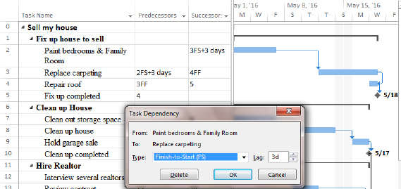

1. Task dependency box with 3 day lag time added. [6-13 Tasks with lag time.tif]

Lag time may also be expressed as a percentage of the duration of the predecessor task. Order equipment is a 5 day task. 50% Lag would mean that the length of the lag time would be 2.5 days or half of the 5 days duration of the Order equipment task.

## What is Lead Time?

Lead time shortens the time line of the project. Consider tasks that do not need to be 100% completed before the successor task can start. Lead time is a good tool to help refine the schedule when trying to cut time from a timeline. Project 2013 does not have a field or box called Lead time. Instead, to create Lead time negative Lag time is entered.

To create Lead time:

The view below is showing that Task 7 “Clean out storage space” should be completed before starting Task 8 “Clean up house.” Each task will take 5 days for a total duration of 10 days plus weekend time to complete this work. If other resources were available to help clean the house, this task could start earlier and save total time to complete both tasks.

Below is a view of the tasks before lead time is entered. Note the total duration for the 2 tasks and the milestone ending date of 5/17.

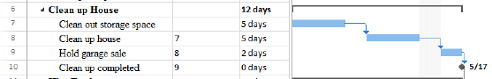

1. Tasks without Lead time. [6-15 Tasks without Lead time.tif]

To enter Lead time between two tasks:

Double click the relationship line between tasks where lead time is to be added.

Enter “-3d” in the Lag field value

Click OK to close the box

Below is the result of adding lead time between two tasks. Note the overlap of tasks and the total scheduling time has been shortened. Note the value in the predecessor column and in the Lag box in the Task Dependency box. Compared to the view without lead time, the milestone for this group of work is now scheduled 5 days sooner.

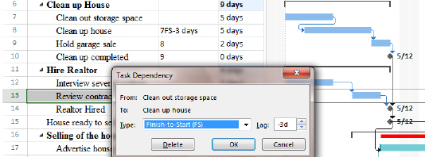

1. Tasks with Lead time [6-17 Tasks with lead time.tif]

Lead time can also be expressed in percentages. The advantage to using percentages is if the predecessor task length changes, the successor task will automatically adjust its starting date.

For example:

* Task A is 10 days long and has a Finish-to-start relationship with Task B with -50% lead time
* Task B will be scheduled to start when Task A has 5 days of work completed
* Task A is taking longer than expected and is now scheduled to take 15 days
* Task B will be rescheduled to start when Task A has 7.5 days of work 7.5 days of work is scheduled to be completed.

A -50% would move the successor task to the left 50% of the duration of the predecessor task. Figure #.17 demonstrates the result of applying -50% for Lead time to the relationship between these two tasks.

To enter Lead time between two tasks as a percentage value:

* Double click the relationship line between tasks where lead time is required.
* Enter “-50%” in the Lag field value
* Click OK to close the box

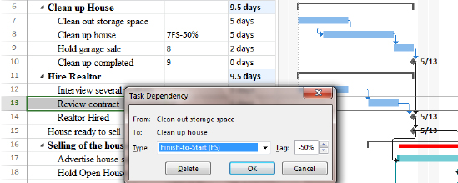

1. Lead time entered in a percentage. [6-18 Lead time percentage.tif]

## Best Practices Using Lead and Lag Time

Best practices for the use of Lag time in a project schedule. Add Lag time when:

* Time must go by without a work or cost applied to the time. Lag is considered to be wait time like a delivery of equipment or concrete hardening.
* You would like to add slack into the schedule to extend the timeline to allow for possible contingencies during project execution.
* You would like to add wait or cushion time between phases of a project
* You would like to add wait time between parallel sections of a project to allow others to catch up.
* Lag time may also be expressed in elapsed time to allow nights and weekends to be included
* Planning the work for a factory crew. For example: the crew needs to be at work for 9 hours but 8 of that is actual work. The remaining hour is meal and breaks. Use Lag to extend the time for the work of the crew to accommodate breaks.

Use lead time when the schedule needs to be shortened. More resources will be needed to accomplish the tasks. Lead time can increase risk of re-work and could increase cost for tasks.

Best practices for the use of Lead time in a project schedule:

* Piece work – when X number of items or time has been completed, give the completed work to the next group to start their work.
* Testing – when X percentage of the testing is completed and successful, give the completed work to the next group to start their work.
* When it is not necessary for the predecessor task to achieve 100% completion before starting the successor task.

# Inactivate Tasks

When developing a schedule or even after a schedule is being executed, you may have portions of the schedule that may be optional or you may be looking for ways to run a scenario which leaves out a portion of the schedule from the scheduling engine. Choosing to inactivate a collection of tasks is a way to temporarily or permanently remove tasks from the rest of the schedule, but still leave the information about those tasks intact so you can reactivate them at a later time as desired, or keep this inactive data for historical purposes. This feature saves time over having to delete and re-enter task information. All tasks by default are active unless you make them inactive.

This feature is in Project Professional 2013 only.

To inactivate a task:

1. Select the task(s).
2. On the Task tab, Schedule group, click Inactivate.

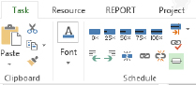

1. Section of the Task ribbon with Inactivate button. [6-19 Inactivate tasks.tif]

In figure #.19 all of the tasks are active:

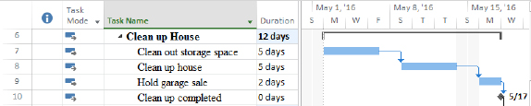

1. View of active tasks. [Active tasks.tif]

It has been decided that the “Clean the House” task is not needed for the project schedule. In the view below you will see the result of adjusting this task to inactive status. Notice the changes to the schedule. The “Clean up House” task has a line through its name and is shadow formatted. The task bar for the task is clear and the predecessor task has been re-scheduled to accommodate for the inactivated task.

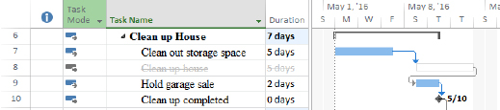

1. Inactivated tasks [Inactivated tasks.tif]

If you made a mistake and accidentally inactivate the wrong task(s), simply click Inactivate again to make them active.

This feature is especially useful when you are struggling with test/retest cycles. Simply inactivate the extra cycles until they are needed.

Inactive tasks are a great way to include contingency actions which only apply if a planned risk actually manifests itself in the future.

# Key Points to Remember

* Project applies a formula when scheduling tasks.
* Estimating is done in either a top down or bottom up approach.
* Both task information and resource information is estimated.
* Good estimates come from individuals who perform the work or historical information.
* Project includes a ? symbol in every duration cell where a numeric value has not been actually entered as a reminder.
* Dynamic scheduling means that linked tasks will respond to changes in the schedule as long as the tasks are auto scheduled.
* Sequencing is the concept of putting things in a logical order in your schedule.
* There are four dependency types with Finish to Start as the most common.
* A predecessor is a task which comes before another task in a Finish to Start relationship.
* A successor is the task which comes after another task in a Finish to Start relationship.
* Use only necessary links to establish relationships.
* In a Finish to Start relationship lag time provides for an additional waiting period before the successor task starts.
* In a Finish to Start relationship, lead time provides for an overlap between the two tasks and is entered as a negative number.
* Lead time may be useful when trying to shorten the timeline.
* Inactivate tasks instead of deleting tasks to leave a visual reminder that the tasks are not currently needed in the schedule.